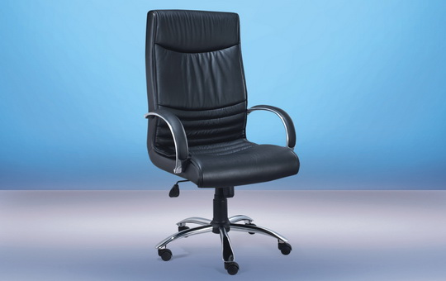


THE EMERALD LEATHER EXECUTIVE CHAIR.

Full Grain Cow Leather, Rock and Lock Mechanism, With Tension Adjustment.
Steel Base Chrome tested to 1.5 tonne.
Polished Alloy Arms With Leather Insert.
ONLY $215.00 + GST
High Back Only

